# VBA Challenges:

The challenge is to write the script for the data of the stock market in the excel workbook.

## Background:

VBA is a type of application that is basically a programming language created by Microsoft and also owns it. It is basically made to repeat a particular task which is run in the form of macros. They are also used for the functions of data processing. Which helps to make the reports and graphs. It is integrated into MS office. This can be checked by enabling the developer option in the column.

It’s not the only product for the developers to create scripting in excel Microsoft has provided many more such options.

In this, the dataset has the 3 years of data which are about to be 2018, 2019, and 2020. These data are separated inside the tab in the workbook

## About scripting:

The scripting has been written by testing on the sample file which is named the (alphabetical_testing.xlsx) as it contains fewer data and the script runs easier. Then the script has been run over the main file.

The script is uploaded to the repository which is named the VBA script in bas format. It can also be seen after downloading the excel file. Go to the developer option and click on the visual basic. As the running of the script is done. It does the following:

Scripts loops through all the stocks for one year and output the following information:

* The ticker symbols
* Yearly change from the opening price at the beginning of a given year to the closing price at the end of that year.
* The percentage change from the opening price at the beginning of a given year to the closing price at the end of that year.
* The total stock volume of the stock
* Does the conditional formatting in green for a positive year and red for a negative year?
* Gives the greatest percent decrease, greatest percent increase, and greatest total volume.

# Output:

The output for the script will look like this for the year 2018: 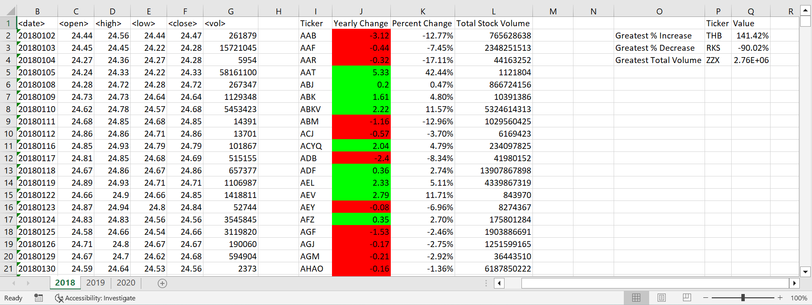

For 2019:

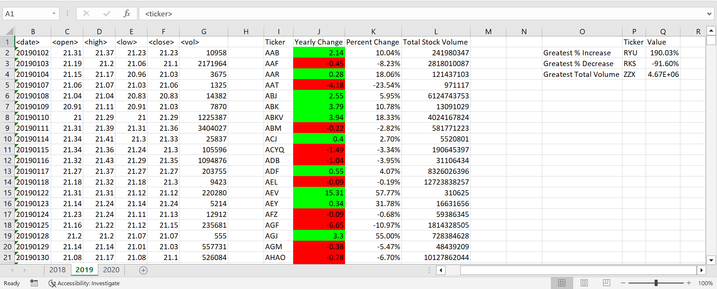

For 2020:

